Etton Parish Council
Ettonparishcouncil.eastriding.gov.uk

Document Reference: 25/26-4

Etton Parish Council – Minutes of the Extraordinary Meeting of Council held on the 16th June 2025 at 19:30 in the Village Hall.

Present
Cllr. David Heuck |  | DH | Chairman
Cllr. Stuart Bell |  | SB | Vice Chairman
Cllr. John Sleight |  | JS | Councillor
Cllr. Richard Yeo |  | RY | Councillor
Cllr. Gareth Williams |  | GW | Councillor
Cllr. Ian Napper |  | IN | Councillor
Officers
Catherine Simpson |  | CS | Clerk
Others
 |  | 5 | Members of the public
 |  |  |  | Action
 | WELCOME
 | The Chairman welcomed everyone to the meeting and read the Recording Declaration.
25/26-30 | APOLOGIES FOR ABSENCE
 | Apologies were received from Cllr. John Holmes and Ward Cllr. Jeremy Wilcock and the reasons approved.
25/26-31 | DECLARATIONS OF INTEREST & DISPENSATIONS
There were no declarations of interest.

Cllr. David Heuck read the following statement:

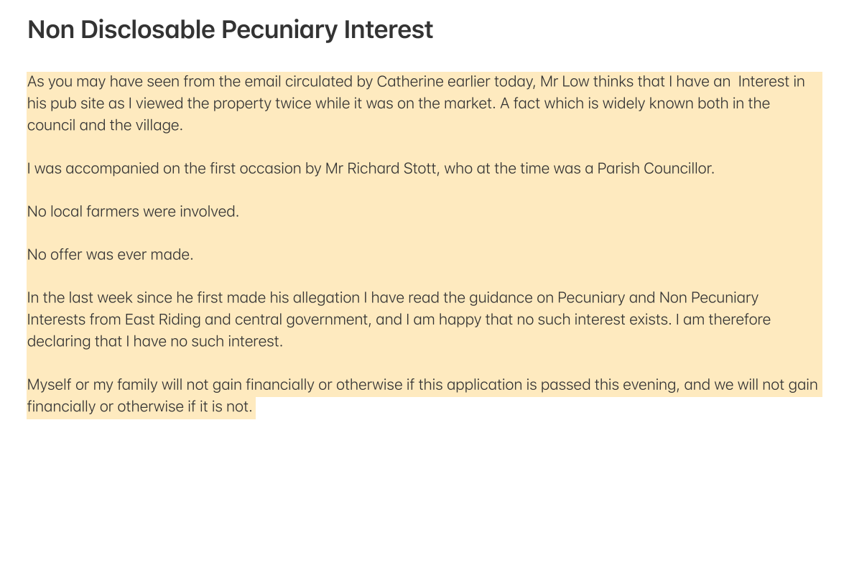

25/26-32 | PLANNING
25/01474 – Land West of the Light Dragoon, 34 Main Street, Etton, HU17 7PQ

Proposal: Erection of 2 dwellings with detached garages, construction of vehicular access and associated landscaping and parking.

RESOLVED: that Council unanimously object to the application on the following grounds:

There is insufficient provision for parking and insufficient sewage infrastructure. There was also a concern that the application constitutes over development of the site and will be detrimental to the conservation area.

25/26-33 | DATE OF NEXT MEETING
 | The next meeting will take place on the 14th July at 19:30.

Meeting finished at 19:45

Signature of Chairman:

Clerk: Catherine Simpson, 19 Princess Road, Market Weighton, Y043 3BX , telephone 01430 872239
Telephone: 01430 872239 /Email: ettonpc@outlook.com

